Clearing House Group

Clearing.house@tcs.com

Abstract

This document provides the list of requests which need to be raised with specific details for onboarding a new member on the Azure Migration Project

Onboarding new users to Azure migration team

SOP Document

Contents

SpecCo Requests: 2

Creating new myaccess user account 2

CPASS, DDNET1, HYPERRAS Assets 3

DDNET2 User Account Request 5

Addition as member to AD Groups (Team; ADMIN/APP/DBA; FW_PHI_AZURE_SQL) 5

Azure-PreProd-Network-Access Asset 6

VSTS Basic License 6

AgCo Requests: 7

Create PHIBRED and PHIEXT accounts 7

Addition as member to AD groups (Team; ADMIN/APP/DBA; FW_PHI_AZURE_SQL) 7

POSIX Attributes to access Linux Servers 7

VSTS Basic license 8

TCS Communication 8

Add user to DupOffshore/Onshore/Leads TCS Distribution List: 8

## SpecCo Requests:

### Creating new myaccess user account

Clearing house does the following to get the CPASS ID of a user

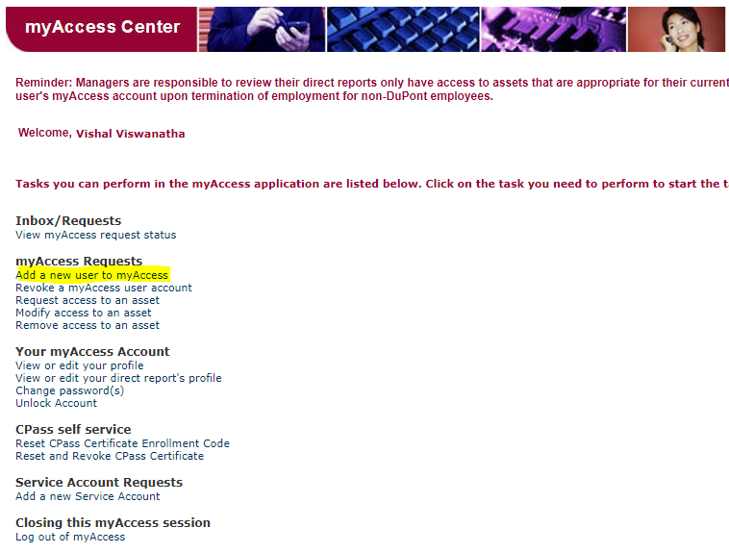

1. Click on “Skip Search - Validated”
2. User Type = “Contractor”
3. Company = “ Tata Consultancy Services – IT”
4. Are you the Responsible Manager for this new user? = “No”
5. Search Attribute: «myAccess ID» «starts with» «ht6171»; Ravi Motamarri’s details should pop up after clicking continue
6. Fill in the below details:

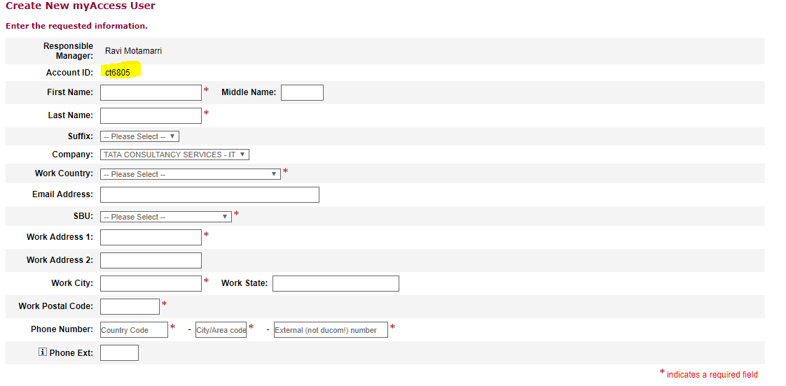

1. Click continue/submit to finish the procedure, Note the highlighted portion as this will be your cpass id.

### CPASS, DDNET1, HYPERRAS Assets

1. Login to myAccess and click on the link highlighted in yellow:

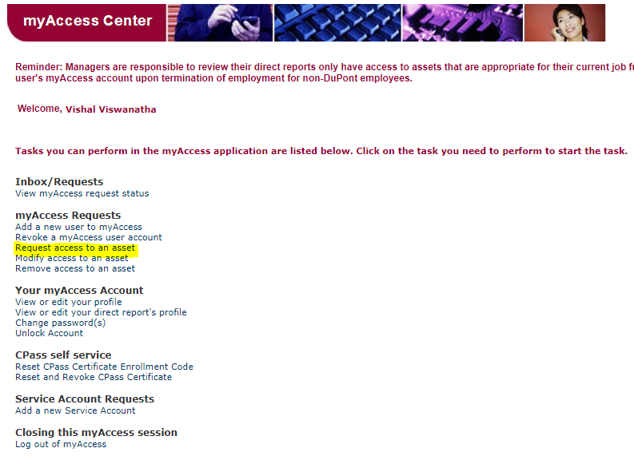

1. Select “This request is for someone else”
2. Input the First Name/Last Name/myAccess ID/ Email ID for the person
3. A page appears showing the Approver, click continue
4. The below page will appear:

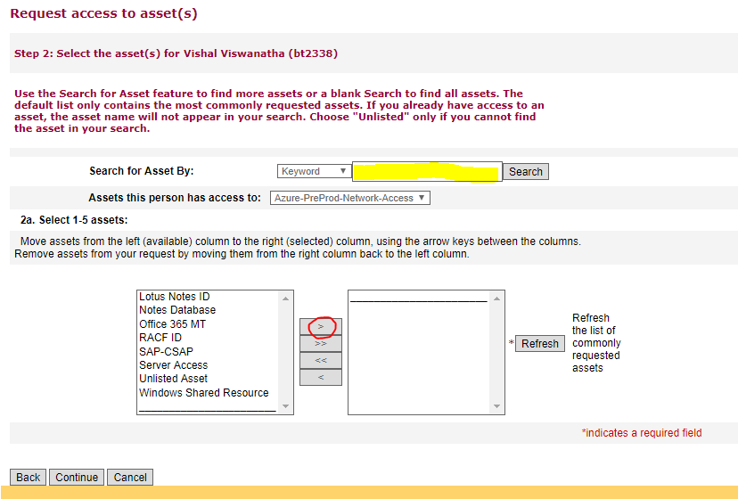

1. Write “DDNET1” in the yellow box and hit Search, the results should appear in the leftside box below
2. Click on the “>” button encircled in red
3. Repeat this process for “hyper” and select “HyperRAS”.
4. Repeat this process for “cpass” and select “CPASS”
5. Enter the business justification as to why the user needs the three assets

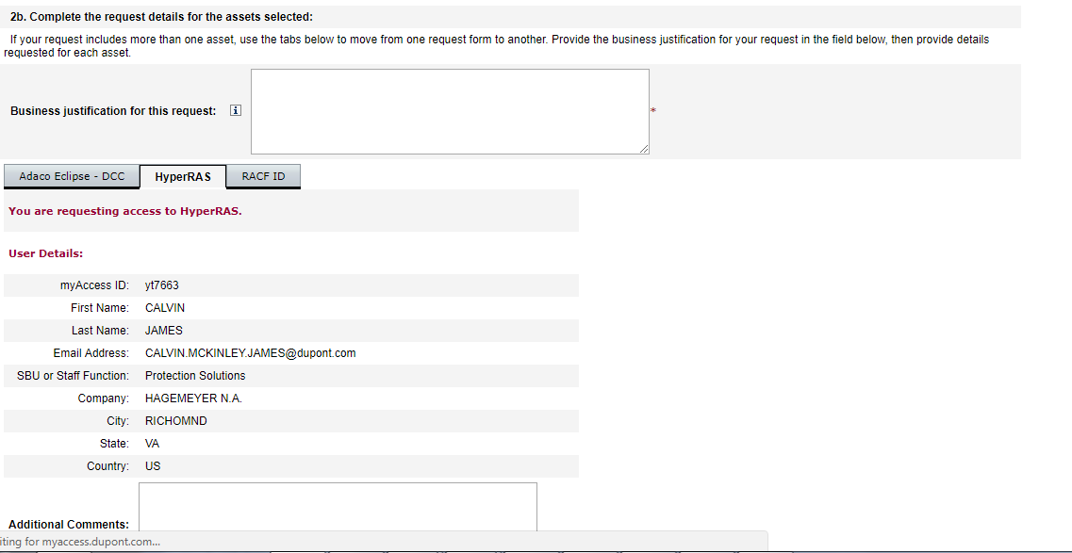

1. Then we click on the tabs individually (you can see HyperRAS is selected above, the other 2 are dummy selections for the sake of documentation) and fill in the Additional Comments sections in each.
2. While filling Cpass Section please note that you need to provide the delivery address of your device, please contact your manager for getting these details
3. Upon submitting the request we get 3 ARN numbers, one each for the three assets that were raised.

### DDNET2 User Account Request

To create a DDNET2 account following the below steps:

1. Go to myAccess > Request access to an asset > Request is for self
2. Selected Unlisted asset, as given in the screenshot below:

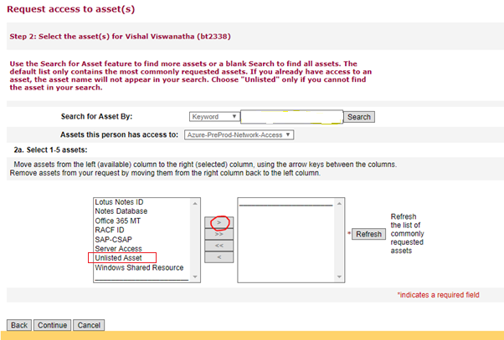

1. Provide business justification
2. Unlisted Asset Name = DDNET2
3. Provide Additional details
4. Select Asset Owner as Gary Young, myAccess ID; mv6153
5. Submit
6. Get the ARN
7. Get the request approved by your Responsible Manager and Gary Young
8. Once Gary approves you’ll receive a REQ number from myAccess in your registered email ID
9. Login to SOM and assign that REQ# to Dup-TCS-Active-Directory-Services Implementation group
10. Follow up with the AD team ( they sit in S1 6th floor Adibatla) to get the account created

### Addition as member to AD Groups (Team; ADMIN/APP/DBA; FW_PHI_AZURE_SQL)

User needs to be added to the following AD groups:

1. TCS-AZURE-MIGRATION-TEAM: Members of this group will be able to access the Azure Portal, VSTS and TFS.
2. TCS-AZURE-MIGRATION-ADMIN/TCSAZMIG-APP/TCSAZMIG-DBA: Depending on the role of the user – server administrator/application developer/database administrator, the user has to be added to one of the above mentioned AD groups. Membership will ensure server access to majority of the servers in SpecCo.
3. FW_PHI_AZURE_SQL: Membership to this group will ensure that users are able to access PaaS Databases from their client/local machines.

Process:

Clearing House will consolidate request for all the AD groups in a single myaccess unlisted asset request with asset owner as Rob Clark (eu6311).

### Azure-PreProd-Network-Access Asset

This asset is required in myaccess to access PRE-PRODUCTION Iaas over common web and database ports. For accessing our IaaS VM’s and getting RDP Access, this asset is required.

Clearing House will raise the request in myaccess on behalf of the user.

Process:

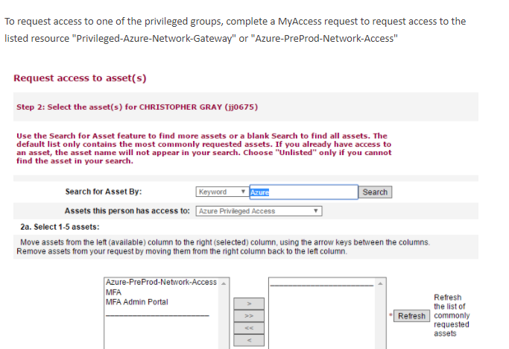

### VSTS Basic License

To access the code and build sections of the VSTS, sometimes just membership to the TCS-AZURE-MIGRATION-TEAM is not sufficient. Hence if the user confirms to the Clearing house team that they are able to access the VSTS but not the code and build sections, Clearing house will request TFS Admins (send a mail to TFSAdmins@pioneer.com) for attaching a basic VSTS license to the user for DuPont VSTS (<https://vs-dupont.visualstudio.com)>

## AgCo Requests:

### Create PHIBRED and PHIEXT accounts

Clearing house will send a mail to Tracy Worden ([tracy.worden@pioneer.com](mailto:tracy.worden@pioneer.com)) with user details (CPASS ID, Name, Email ID) to create the PHIBRED and PHIEXT accounts.

*Sample Email:*

*We need your help to create Phibred and Phiext User accounts(Username+Password) for the following users:*

|  |  |  |
| --- | --- | --- |
| *​Cpass Id* | *​Employee Name* | *​Mail Id* |
|  |  |  |

*The users also require access to Agco 6.0 subscription so please add the above IDs to TCS-Azure-Migration-Team AD group once the Phibred and Phiext user-accounts are created. Request you to also initiate the switching of  the UPN to* [*username@agcompany.net*](mailto:username@agcompany.net)*.   
  
Please let us know if you need any further information*.

### Addition as member to AD groups (Team; ADMIN/APP/DBA; FW_PHI_AZURE_SQL)

User needs to be added to the following AD groups:

1. TCS-AZURE-MIGRATION-TEAM: Members of this group will be able to access the Azure Portal, VSTS and TFS.
2. TCSAZMIG-SVR/TCSAZMIG-APP/TCSAZMIG-DBA: Depending on the role of the user – server administrator/application developer/database administrator, the user has to be added to one of the above mentioned AD groups. Membership will ensure server access to majority of the servers in AgCo.
3. FW_PHI_AZURE_SQL: Membership to this group will ensure that users are able to access PaaS Databases from their client/local machines. Request needs to be approved/sent by a Pioneer Manager (Fox, Todd [TODD.FOX@PIONEER.COM](mailto:TODD.FOX@PIONEER.COM))

Process:

Clearing House will use the below form to send a request to LAN Security Team in Pioneer to add the users to the AD groups for each AD group:

http://phiweb.phibred.com/helpzone_forms/ChangeSecurityLanGroup.htm

### POSIX Attributes to access Linux Servers

To access Linux servers in PHIBRED domain, each CPASS user and service account needs to be UNIX enabled by adding POSIX attributes to their profile.

Reference: https://dupont.sharepoint.com/teams/teams_azure_app/howto/Lists/Posts/Post.aspx?ID=19

Clearing house raises a request using the link UNIX from the form: <http://mypioneer.phibred.com/portal/site/pioneerdev/menuitem.035f4f37ae14eed3dcca69f1c00093a0/>

Few Details to fill the form:

* Remote Access Group: RA-{tcsazmig}
* Shell: /bin/bash
* Primary Group: US-{tcsazmig}
* Additional comments: Add a comment indicating this is for access to an Azure VM

### VSTS Basic license

To access the code and build sections of the VSTS, sometimes just membership to the TCS-AZURE-MIGRATION-TEAM is not sufficient. Hence if the user confirms to the Clearing house team that they are able to access the VSTS but not the code and build sections, Clearing house will request TFS Admins (send a mail to TFSAdmins@pioneer.com) for attaching a basic VSTS license to the user for Pioneer VSTS (<https://vs-pioneer.visualstudio.com)>

## TCS Communication

### Add user to DupOffshore/Onshore/Leads TCS Distribution List:

Depending on the role of the member, the user’s TCS email ID has to be added to the one/more of the following distribution lists:

|  |  |  |
| --- | --- | --- |
| **Name of the DL** | **Email ID of the DL** | **DL Admins to be contacted** |
| DupOffshore Leads grp | DupOffshore.Leads@tcs.com | satabdi.senapati@tcs.com  ravi.motamarri@tcs.com |
| DupOffshore Team Grp | DupOffshore.Team@tcs.com | satabdi.senapati@tcs.com  ravi.motamarri@tcs.com |
| DupAzure Team Grp | DupAzure.Team@tcs.com | vishal.viswanathan@tcs.com  ravi.motamarri@tcs.com |
| DupOnshore Leads grp | DupOnshore.Leads@tcs.com | satabdi.senapati@tcs.com  ravi.motamarri@tcs.com |